

QUALITY MANAGEMENT PLAN

**Version1.0**

**Quang Vuong**

**04/11/2019**

**VERSION HISTORY**

|  |  |  |  |  |  |
| --- | --- | --- | --- | --- | --- |
| **Version #** | **Implemented**  **By** | **Revision**  **Date** | **Approved**  **By** | **Approval**  **Date** | **Reason** |
| 1.0 | Quang Vuong | 4/11/2019 | Đạt Huỳnh | 5/11/2019 | Release Quality Management Plan |
|  |  |  |  |  |  |
|  |  |  |  |  |  |
|  |  |  |  |  |  |

Contents

1. Introduction 3

2. Scope 4

3. Role and Responsibility 4

4. Quality Assurance Activities 4

4.1. Manage Schedule 4

4.2. Methodologies 4

4.3. Risk Management 5

4.4. Tools 5

## Introduction

This document includes all the activities of the performing project team that determine methodologi, objectives and responsibilities so that the project will satisfy the needs for which it was undertaken.

The Quality Management Plan include:

* Scope
* Role and responsibility
* Manage schedule
* QA
* Risk management
* Tools

## Scope

The Quality Management just release process and how management schdule, quality assurance...

## Role and Responsibility

|  |  |  |
| --- | --- | --- |
| No | Role | Responsibility |
| 1 | Author | Responsible for Quality of document or code |
| 2 | Leader | Responsible for Approval |
| 3 | Tester | Responsible for delivery testcase and execute testcases |

## Quality Assurance Activities

### **Manage Schedule**

### **Methodologies**

#### **Review Document Process**

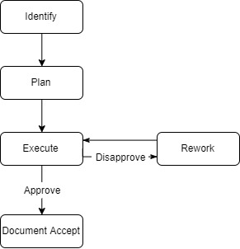



##### **Review Document Process Description**

|  |  |
| --- | --- |
| Quality Assurance Description | |
| Purpose | Review document to ensure documents are in compliance |
| Inputs | Document need to be review, document config |
| Activity steps | 1. Identify: identify what is document need to be review 2. Plan: Describe standard, criteria... 3. Execute: Action review then have 2 result are approve or disapprove. If result is approve, go to step 5 and result is disapprove, go to step 4 4. Reword: author have responsibility for reword document if that document wasn’t approve 5. Document accepted: the document pass criteria and approved |
| Roles | Leader, author |
| Outputs | Document approved |

#### **Code review process**

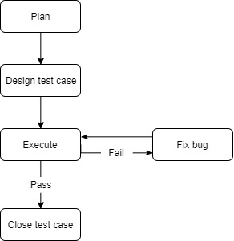

##### **Code Review Process Description**

|  |  |
| --- | --- |
| Establish Policy Process Description | |
| Purpose | Make ensure soure code works well, limiting errors |
| Inputs | Document requirement(use case,...) |
| Activity steps | 1. Plan: Identify what’s feature will be test and criteria 2. Design test case: Tester design test case base on requirement(use case,..) 3. Execute: Execute test case and will have 2 result are fail or pass. If the result’s fail, go to step 4 or result’s pass, go to step 5 4. Fix bug: developer(author) fix bug that tester report |
| Roles | * Tester * Author |
| Outputs | * Test case fail: report to developer * Test case pass: report test case done. |

### **Risk Management**



### **Tools**

* Excel